Using a Virtual Machine on Remote Desktop via Azure (beginner friendly)
This project demonstrates how to deploy a Virtual Machine (VM) on Azure and access it remotely using Remote Desktop Protocol (RDP). The goal is to set up a Windows Server 2022 VM, configure networking, and establish an RDP connection

Technologies Used
- Environments: Microsoft Azure
- Operating System: Windows Server 2022
- Services Used:
  - Azure Resource Group (vpn-winserv2022)
  - Azure Virtual Machines
  - Remote Desktop Protocol (RDP)
Deployment Steps

Step 1: Create a Resource Group
- Log in to Azure Portal.
- Go to Resource Groups → Click "Create" → "Resource Group".
- Configure the resource group settings: Image below
- Click "Review + Create" → "Create".
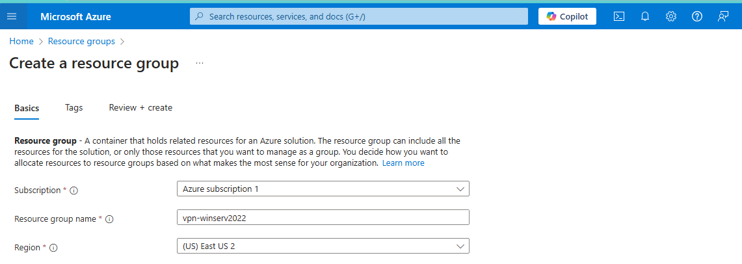

Creating a Virtual Machine on Azure
- Log in to Azure Portal.
- Go to Virtual Machines → Click "Create" → "Azure Virtual Machine".
- Configure the VM settings: 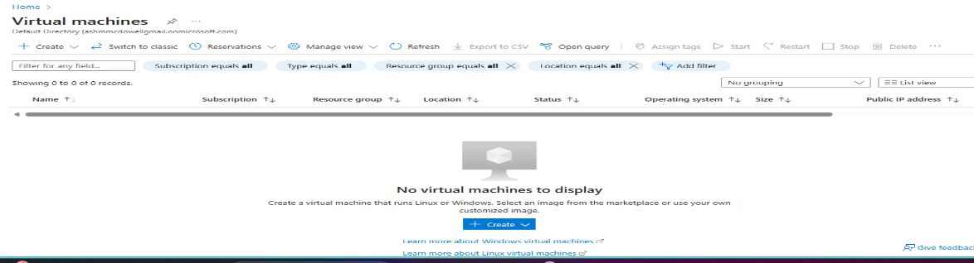
  - Resource Group: (vpn-winserv2022)
  - VM Name: vm-WinServ2022
  - Region: Select a data center near your location
  - Image: Windows Server 2022
  - Size: Standard_B2ms (2 vCPUs, 8GB RAM)
  - Administrator Username: Labuser123
  - Password: Set a strong password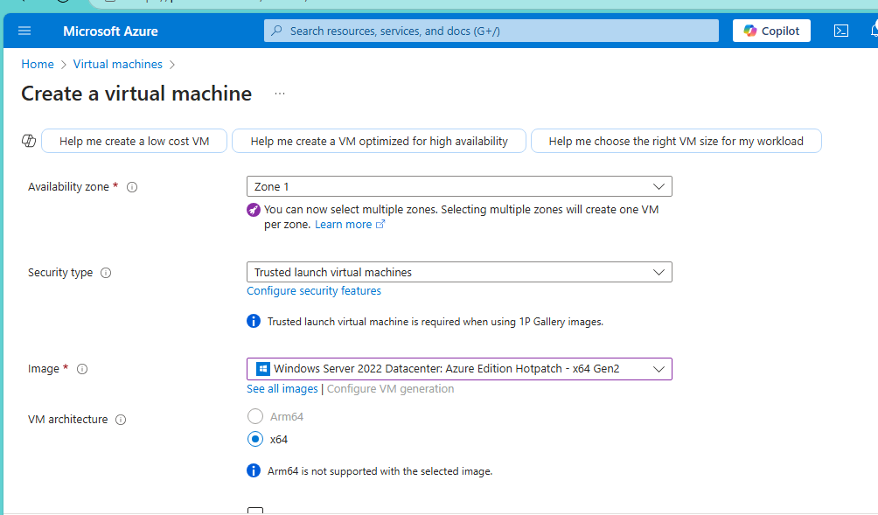
  - Ensure RDP (Port 3389) is selected
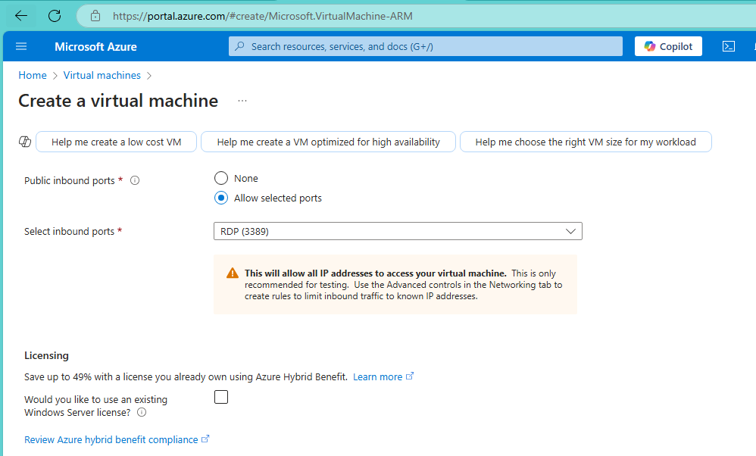
9.select inbound port Click "Review + Create" → "Create".

Step 2: Configure Networking for Remote Access
- Go to Azure Virtual Machines → Click on your VM.
- click on VM then go to the public IP address to the right, select and copy
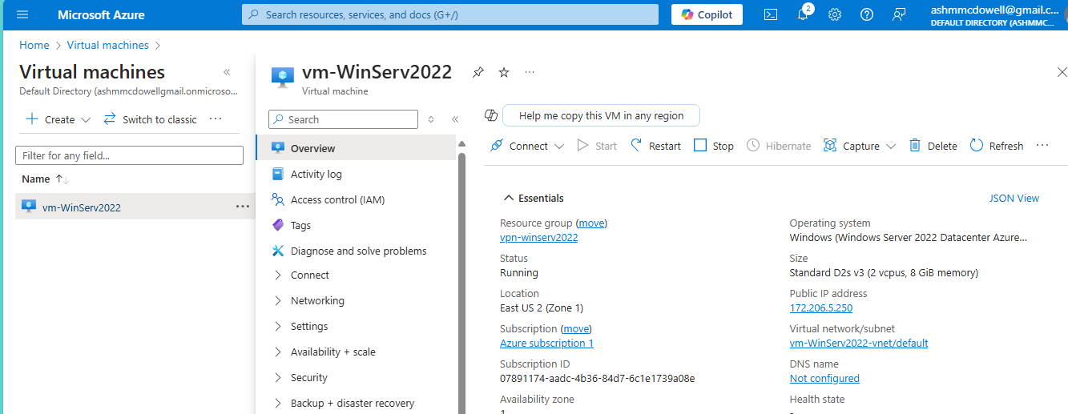
- go to your computer search bar and type in Remote Desktop Protocol (RDP).
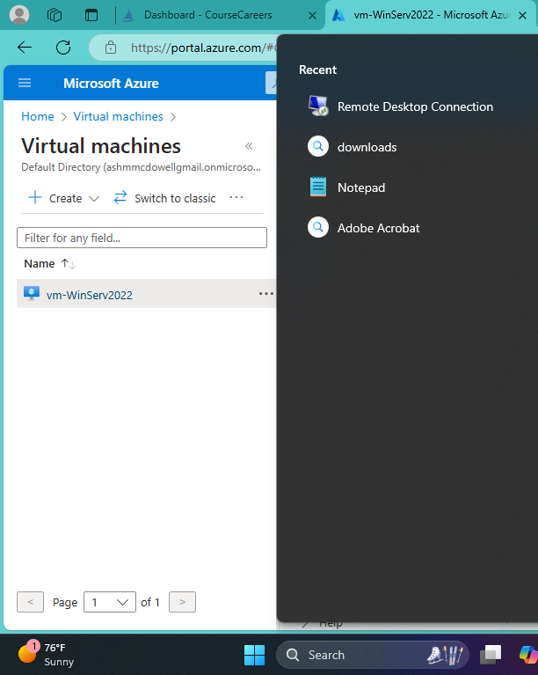
- take the copied IP address and input into Remote Desktop Protocol (RDP).
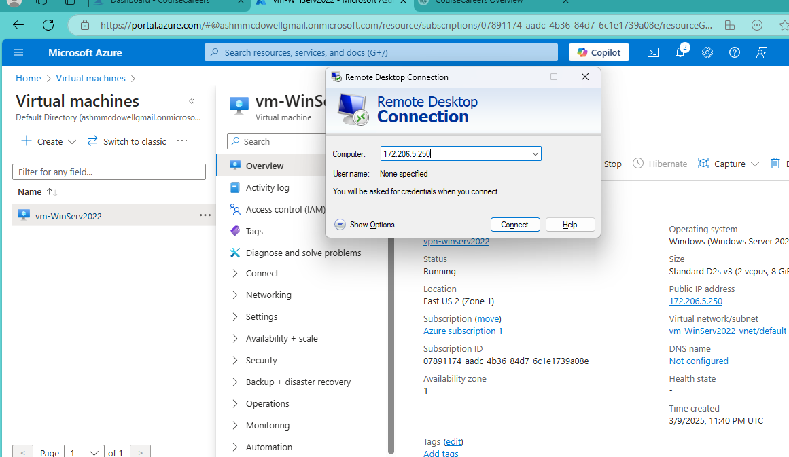
- After you hit connect, type in username (Labuser123) and password you created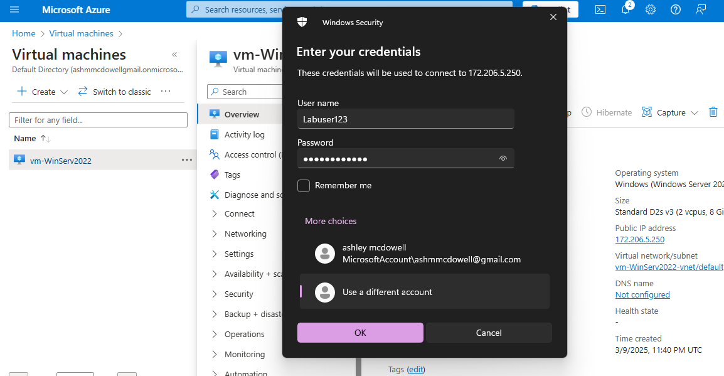

- and then select yes when the prompt is presented
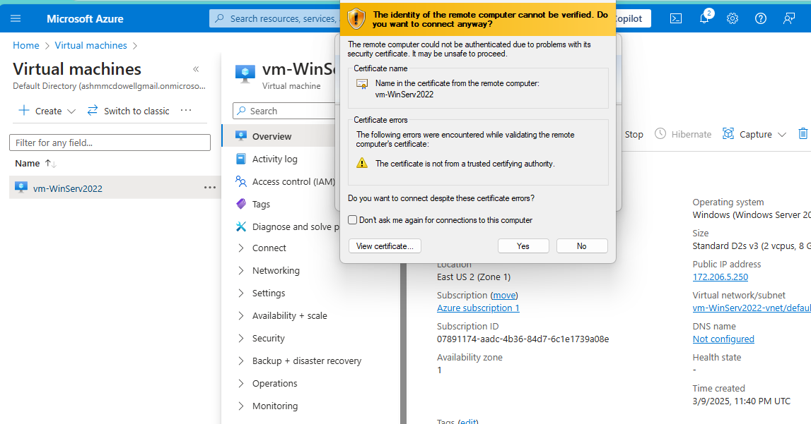
- Now you should be successfully connected to the virtual machine.

